**S&P 500 Time Series Analysis**

**Introduction**

The S&P 500 dataset, spanning several decades from 1950-2020, provides an overview of the stock market's performance, primarily focusing on closing prices and their logarithmic transformations. This analysis aims to dissect the dataset into trend, seasonality, and noise components.

**Data Visualization**

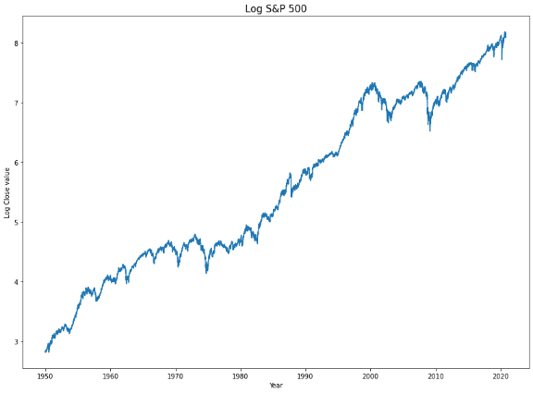

On the left chart we have the original S&P 500 close price we can see it has a general upward trend, on the right chart we can see the log close price which behaves linearly thus we can say that the original close price is growing exponentially. I will continue the work with the Log close price.

**Decomposition of Trend, Seasonality, and Noise**

The Log close price was decomposed to isolate its trend, showing a consistent long-term growth, seasonality, indicating annual fluctuations, and noise. This decomposition was by using statsmodels.tsa.seasonal.seasonal_decompose

